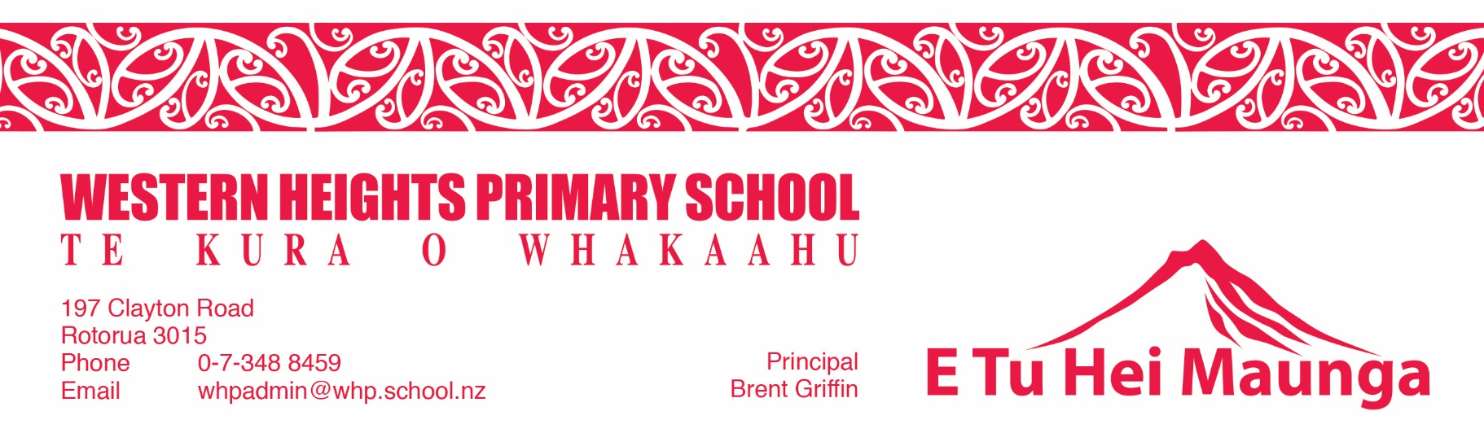
Physical Education, Health and Wellbeing 2023

Physical Education, Health and Wellbeing is a high priority area for Western Heights Primary School. We understand the importance of physical fitness and physical and mental health.

Western Heights being located in a low socio-economic area means our Kura has to take on a greater responsibility to ensure that we do our part to promote and encourage good all round healthy living.

All children will be involved in 2 x 35-40 minute specialist Physical Education classes per week and the classroom teacher runs as third session. All classes are involved in annual learn to swim classes which runs separately to the specialist Physical Education Program.

We want our students to be active at school in their lives.

In 2023 our Specialist PE Teachers have introduced the Perceptual Motor Programme into our Kura. It focuses on developing perceptions and understanding of yourself through motor experiences, using your body. It also helps children to refine gross motor skills to prepare the brain for formal classroom learning.

Every year a budget of $5800.00 is set aside for Kiwi Sport that allows us to purchase necessary equipment for the Specialist PE Programme. The school also tops this budget up when required.

Many sports are offered to our children ranging from rock climbing, gymnastics , mountain biking to your traditional sports of netball, rugby, rugby league and miniball.

Sports like soccer and club rugby are offered to our tamariki via official Bay of Plenty Associations.

We enter all sporting events even if they are new experiences for our tamariki. Rock Climbing was a new addition this year.

We are also part of the Ka Ora Ka Ako Free School Lunches Programme where all children receive a nutritional lunch everyday . This supports our physical health and physical well-being programme. Ka Pai Kai are our lunch providers.

Our group of beautiful Teacher Aides lead by Whaea Karina run Breakfast club every school day morning. They feed between 100 and 150 children daily. A good breakfast sets our tamariki up for a great day of learning.

Mental Health for young children has become a big issue. Trauma in the home is the catalyst to most of the problems. As a school the teachers are involved in Professional Development to enhance our knowledge to support our tamariki. All staff attended a full day workshop run by Henry Hill Schools Principal, Jase Williams. We are also following Dr Bruce Perrys work.

A recent addition is our regulation room, a safe, calm space for children to go to at breaktime to engage in regulatory activities so that they can return to class after break time regulated and ready to learn.

All classes start their day with Yoga and Karakia. When we feel regulated, calm and relaxed we are excited about our learning. Calm kids are happy kids.

We are a ‘Leader in Me School’ that focuses on our tamariki becoming leaders in our Kura and society in general. When our students are recognised for being a leader and being a great citizen their self-esteem and mana grows. A proud child succeeds.

We are also a water only school and we are committed to reducing the students intake of sugary drinks that have such a detrimental effect on their dental health and health overall.

We are also a bronze accredited Sunsmart School. We ensure our students are safe whenever entering the sun during our summer terms. Hats and hydration.

The Health aspects of the Physical Education and Health Curriculum are covered in the Year Level Waka Blueprint planning.

Twice weekly our Community Nurses attend our Kura. They attend to the health needs of our tamariki and on the odd occasion staff health.

Whaea Keegan is our Health and Safety Officer and in conjunction with the Board of Trustees she monitors the physical environment to ensure the school is safe and she monitors all aspects around student safety, accidents in the playground, class and health issues.

If you have any questions contact Brent Griffin 3488459

